Source https://www.viator.com/tours/Montego-Bay/Zipline-Tubing-and-ATV-Safari-Adventure-from-Montego-Bay/d432-3991P32
__________________________________________________________

Jamaica Ultimate Adventure Combo: ATV, Zipline, Horseback & Catamaran Experience
__________________________________________________________
★★★★★ 4.7/5 20 reviews

Add to wishlist ♡

__________________________________________________________

9 hours | €225 per person

🏕  Image | 🏕  Image | 🏕  Image | 🏕  Image | 🏕  Image | 🏕  Image

__________________________________________________________
About This Tour
Experience Jamaica’s wild side with this all-in-one adventure day at Ocean Outpost Park. Designed for thrill-seekers and nature lovers, this action-packed tour combines ziplining above the jungle canopy, ATV riding through rugged backcountry trails, horseback riding in the Caribbean Sea, and a lively catamaran cruise. Between adventures, relax with a traditional Jamaican lunch and enjoy stunning views of tropical landscapes and coastline.
__________________________________________________________
What’s Waiting for You
- Duration: 9 hours
- Group Size: Max 15 participants
- Languages: English
- Pickup: Hotel pickup available or direct arrival
- Start Time: 08:30 AM (arrival time)
- Transportation: Air-conditioned transfers from Montego Bay hotels
- Season: Available year-round
__________________________________________________________

Check Dates & Availability

Select participants: (Age 99 and younger) - 1 +

Choose date:
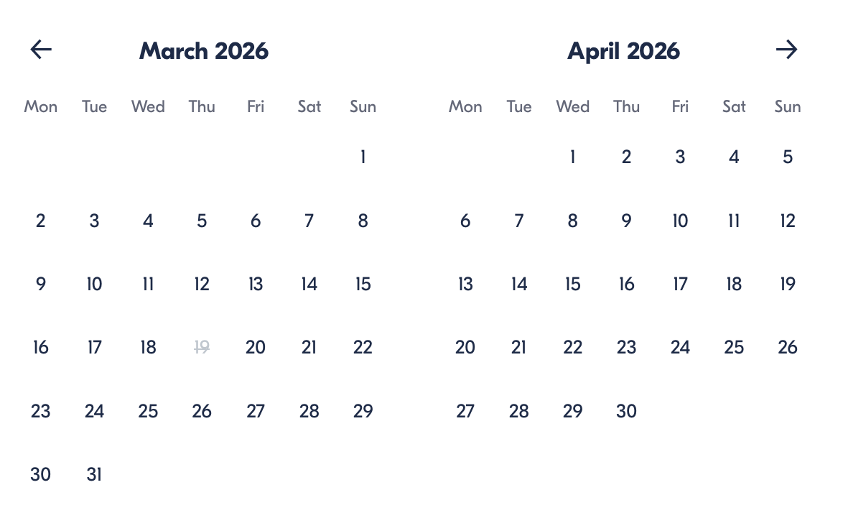

Check Availability

opens:

Participants: 1 March 16, 2026

Jamaica Ultimate Adventure Combo: ATV, Zipline, Horseback & Catamaran Experience

- Start time: 08:30 AM

Cancellation:

- More than 24 hours before start — Full refund
- Less than 24 hours — No refund

Price breakdown: 1 Participant x €225

Total: €225

The total price includes all taxes and fees.

Add to cart Book now

__________________________________________________________
Tour Features
- Zipline through lush jungle canopy and mountain valleys
- Drive an ATV across rugged historic estate trails
- Ride horseback through the Caribbean Sea
- Cruise aboard a party catamaran with snorkelling
- Enjoy river tubing on the Great River
- Explore 18th-century plantation ruins
- Relax at the oceanfront infinity pool and swings
- Traditional Jamaican lunch included
__________________________________________________________
Adventure Highlights

Jungle Zipline Rush
Clip in and soar above treetops while admiring sweeping views of forests, mountains, and river canyons.

River Tubing Experience
Float along the calm sections and gentle rapids of the Great River while spotting tropical wildlife along the banks.

ATV Backcountry Safari
Take control of your ATV and navigate scenic mountain trails, dense vegetation, and countryside terrain.

Horseback Ride & Swim
Ride a trained horse along tropical landscapes before entering the Caribbean Sea for a once-in-a-lifetime swim experience.

Catamaran Cruise Finale
Relax aboard a lively catamaran featuring:
- DJ music
- Snorkelling stop
- Swimming time
- Jamaican rum punch
__________________________________________________________
Included in Price
- Ocean Outpost Park access pass
- Hotel pickup & drop-off
- ATV safari
- Horseback ride & swim
- Zipline adventure
- Catamaran cruise with drinks
- River tubing
- Kayaks & paddleboards
- Traditional Jamaican lunch
- Professional guide
__________________________________________________________
Not Included
- Photos and souvenirs
- Snacks and extra drinks
- Gratuities
- Optional premium experiences on site
__________________________________________________________
Who Should Avoid This Tour
- Pregnant travellers
- Guests with back problems
- People with heart conditions
- Wheelchair users
- Anyone unable to meet weight/activity requirements
__________________________________________________________
Important Trip Info
Arrival vs Pickup: Time selected is arrival time; hotel pickups occur 30–90 minutes earlier.
Fitness Level: Moderate physical fitness required.
Age Rules:
- Minimum age: 6 years for most activities
- ATV drivers must be 16+ with a licence
- Alcohol consumption: 18+
Weight Limits:
- Horseback: 230 lbs
- Zipline: 265 lbs
- Snorkelling: 275 lbs
- ATV: 300 lbs
Facilities: Lockers available for rent (~$10).
Weather: Water activities depend on sea conditions.
__________________________________________________________

Cancellation Policy
- Cancel more than 24 hours before start — full refund
- Cancel within 24 hours — no refund
__________________________________________________________
What Our Clients Are Saying

Overall rating  4.7/5  ★★★★★  Based on 20 reviews | Review summary  Guide 4.5/5  Transportation 4.6/5  Service 4.7/5  Organisation 4.5/5

Filter  - All traveller types  - Couples  - Group of friends  - Families  By star rating  - All star ratings  - 5 stars  - 4 stars  - 3 stars  - 2 stars  - 1 star | Search reviews (e.g., guide)  Sort by:  - Top picks  - Latest reviews  - Best ratings  - Lowest ratings
__________________________________________________________
★★★★★
Laura G. — Spain
Absolutely incredible day. Ziplining and horseback riding in the sea were unforgettable experiences.
★★★★☆
David C. — Canada
Great combination of activities and excellent guides. It was busy at times but still worth it.
★★★★★
Sarah P. — UK
The ATV ride and catamaran cruise were highlights. Perfect mix of adrenaline and relaxation.
See more reviews
__________________________________________________________

Meta tags

Page - Jamaica Ultimate Adventure Combo: ATV, Zipline, Horseback & Catamaran Experience

Title: Jamaica Ultimate Adventure Combo: ATV, Zipline, Horseback & Catamaran Experience | Travellio Global

Description: Enjoy Jamaica’s ultimate adventure tour with ATV riding, ziplining, horseback swimming, catamaran cruise, river tubing, and lunch included.

H1 - Jamaica Ultimate Adventure Combo: ATV, Zipline, Horseback & Catamaran Experience
__________________________________________________________

